The Measurement of Elasticities

General meaning of elasticity of demand:
From the theory of demand we know that the amount of a commodity purchased per unit of time is a function of or depends on the price of the commodity, money incomes, the price of other (related) commodities, tastes, and the number of buyers of the commodity in the market. A change in any of the above factors will cause a change in the amount of the commodity purchased per unit of time. The elasticity of demand measures the relative responsiveness in the amount purchased per unit of time to a change in any one of the above factors, while keeping the others constant.

Price Elasticity Of Demand
The coefficient of price elasticity of demand (e) measures the percentage change in the quantity of a commodity demanded per unit of time resulting from a given percentage change in the price of the commodity. Since price and quantity are inversely related, the coefficient of price elasticity of demand is a negative number. In order to avoid dealing with negative values, a minus sign is often introduced into the formula for e. Letting ΔQ represent the change in the quantity demanded of a commodity resulting from a given change in its price (ΔP), we have
e = 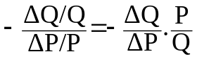
Demand is said to be elastic if e > 1, inelastic if e < 1 and unitary elastic if e = 1.
EXAMPLE 1. Given the market demand schedule in Table 1.1 and market demand curve in Fig. 1-1, we can find e for a movement from point B to point D and from D to B, as follows:

Table 1.1

P_{x}($)
Q_{x}

1000 3000 5000 7000
8

7

6

5

4

3

2

1

0
.
.
.
.
M

.
.
.
.
.
A

B

C

D

F

G

H

L

D_{X}

Fig.1-1
Point | P_{x}($) | Q_{x}
A | 8 | 0
B | 7 | 1000
C | 6 | 2000
D | 5 | 3000
F | 4 | 4000
G | 3 | 5000
H | 2 | 6000
L | 1 | 7000
M | 0 | 8000

From B to D, 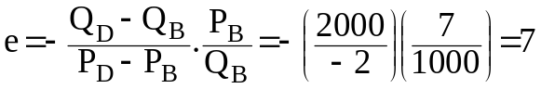
From D to B, 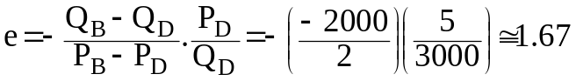

We can avoid getting different results by using the average of the two prices [(P_{B}+P_{D})/2] and the average of the two quantities [(Q_{B}+Q_{D})/2] instead of either P_{B} and Q_{B} or P_{D} and Q_{D} in the formula to find e. Thus,
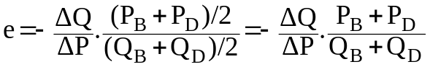
Applying this modified formula to find e either for a movement form B to D or for a movement from D to B we get
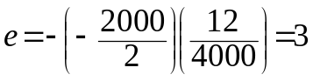
This is the equivalent of finding e at the point midway between B and D (i.e., at point C).
Example-2. Given the market demand schedule in Table 1.2 and the market demand curve in Fig. 1-2, we can find e for a movement from point C to point F, from F to C and midway between C and F, as follows:
Q_{y}

G

D

.
.
P_{x}($)
Fig.1-2
.
.
.
.

2000 4000 6000 8000

7

6

5

4

3

2

1

0
A

.
D_{y}

H

B

C

D©

F

Table 1.2
Point | P_{x}($) | Q_{x}
A | 7 | 500
B | 6 | 750
C | 5 | 1250
D | 4 | 2000
F | 3 | 3250
G | 2 | 4750
H | 1 | 8000

From C to F, 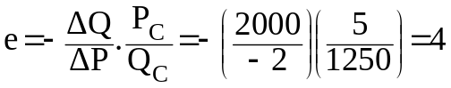
From F to C, 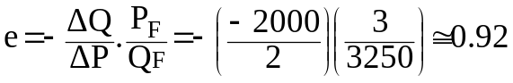
At the point midway between C and F (point D© on the dashed chord),
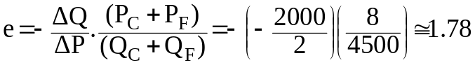

POINT ELASTICITY
Point elasticity of demand: The coefficient of price elasticity of demand at a particular point on a demand curve.

EXAMPLE 3. We can find the elasticity of demand curve in Example 1 at point C geometrically as follows. (For easy reference, Fig. 1-1, with some modifications, is repeated here as Fig. 1-3). Since we want to measure elasticity at point C, we have only a single price and a single quantity. Expressing each of the values in the formula for e in terms of distances, we get:
D_{X}

.
.
.
P_{x}($)
2000 4000 6000 8000
8

7

6

5

4

3

2

1

0
Q_{x}

M

A

C

Fig.1-3
N

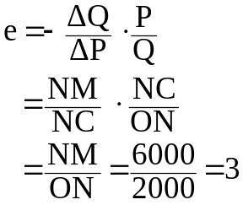

INCOME ELASTICITY OF DEMAND
The coefficient of income elasticity of demand (e_{M}) measures the percentage change in the amount of a commodity purchased per unit of time (ΔQ/Q) resulting from a given percentage change in a consumer’s income (ΔM/M). Thus
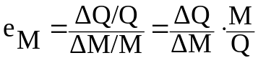
When e_{M} is negative, the good is inferior. If e_{M} is positive, the good is normal. A normal good is usually a luxury if its e_{M} >1, otherwise it is a necessity. Depending on the level of the consumer’s income, e_{M} for a good is likely to vary considerably. Thus a good may be a luxury at “low” levels of income, a necessity at “intermediate” levels of income and an inferior good at “high” levels of income.

EXAMPLE 4. Columns (1) and (2) of Table 1.3 show the quantity of commodity X that an individual would purchase per year at various income levels. Column (5) gives the coefficient of income elasticity of demand of this individual for commodity X between the various successive levels of available income. Column (6) indicates the range of income over which commodity X is a luxury, a necessity or an inferior good.
Table 1.3

(1)  Income (M)  ($/year) | (2)  Quantity of X  (units/year) | (3)  Percent Change  in Q_{x} | (4)  Percent Change  in M | (5)  e_{M} | (6)  Type of Good
8,000 | 5
 |  | 100 | 50 | 2 | luxury
12,000 | 10
 |  | 50 | 33.33 | 1.50 | luxury
16,000 | 15
 |  | 20 | 25 | 0.80 | necessity
20,000 | 18
 |  | 11.11 | 20 | 0.56 | necessity
24,000 | 20
 |  | -5 | 16.67 | 0.30 | inferior
28,000 | 19
 |  | -5.26 | 14.29 | 0.37 | inferior
32,000 | 18

CROSS ELASTICITY OF DEMAND
The coefficient of cross elasticity of demand of commodity X with respect to commodity Y(e_{xy}) measures the percentage change in the amount of X purchased per unit of time (ΔQ_{x}/Q_{x}) resulting from a given percentage change in the price of Y (ΔP_{y} /P_{y} ). Thus
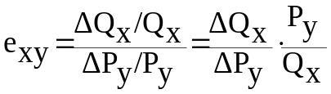
If X and Y are substitutes, e_{xy} is positive. On the other hand, if X and Y are complements, e_{xy} is negative. When commodities are nonrelated (i.e., when they are independent of each other), e_{xy} = 0.
EXAMPLE 5. To find the cross elasticity of demand between tea (X) and coffee (Y) and between tea (X) and lemons (Z) for the data in the next table, we proceed as follows.
Table 1.4 (a)
Commodity | Before |  | After
Commodity | Price  (cents/cup) | Quantity  (units/month) | Price  (cents/unit) | Quantity  (units/month)
Coffee (Y) | 40 | 50 | 60 | 30
Tea (X) | 20 | 40 | 20 | 50

Table 1.4 (b)
Commodity | Before |  | After
Commodity | Price  (cents/unit) | Quantity  (units/month) | Price  (cents/unit) | Quantity  (units/month)
Lemon (Z) | 10 | 20 | 20 | 15
Tea (X) | 20 | 40 | 20 | 35

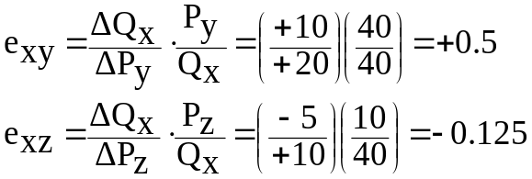
Since e_{xy} is positive, tea and coffee are substitutes. Since e_{xz} is negative, tea and lemons are complements.

